25th June 2019

**YOKOHAMA “GEOLANDAR” Equipped Car Wins Its Class at Australia’s Largest Off-road Race**

YOKOHAMA announced today that a car fitted with its “GEOLANDAR A/T G015” all-terrain tyres for SUVs came in first in the EXTREME 4WD (X4WD) class at Australia’s largest off-road race, the Tatts Finke Desert Race held on 8th-10th June. The victorious car was a Toyota Hilux driven by Tadamitsu Niihori and Murray Kenneth Hynes of the Toyota Racing Development (TRD) team. The superior drivability and durability delivered by the “GEOLANDAR A/T G015” tyres contributed to the victory.   
  
The Tatts Finke Desert Race is a 460km round-trip desert race run through a vast desert wilderness in an inland area of Australia’s Northern Territory known as the Red Centre, which is famous for its thick covering of fine red sand. The TRD team cut 20 minutes off its previous years’ time in the first-leg outward bound trip on day one and then continued its stable run through the desert on day two, when 60 of the 143 vehicles in the race failed to finish within the race’s time limit. The TRD team finished the race at the top of its vehicle class, in large part due to durability of the "GEOLANDAR” tyres, which enabled the team to run for two days over difficult terrain without once needing to change tyres. Driver Niihori said that "GEOLANDAR A/T G015" tyres were selected for their lightweight, which enables the driver to take advantage of the suspension’s movement during a desert race. He added that he was able to concentrate on driving because the tyres provided ample traction and excellent control while racing on deep sand. In addition, the team did not have to deal with flat tyres or other problems during the qualifying round and the finals.   
  
The “GEOLANDAR A/T G015” is an all-terrain tyre that delivers superb drivability and durability in off-road conditions and a comfortable, quiet ride on city streets. The tyre’s design is stylish yet also achieves the powerful image befitting an off-road tyre.   
  
The technology strategy outlined in YOKOHAMA’s Grand Design 2020 (GD2020) medium-term management plan positions motor sports activities as crucial to the company’s effort to be at the vanguard of the development of new tyre technologies. YOKOHAMA is therefore participating in a wide variety of events in Japan and around the globe, from formula and touring car races to rally, off-road, and kart races.

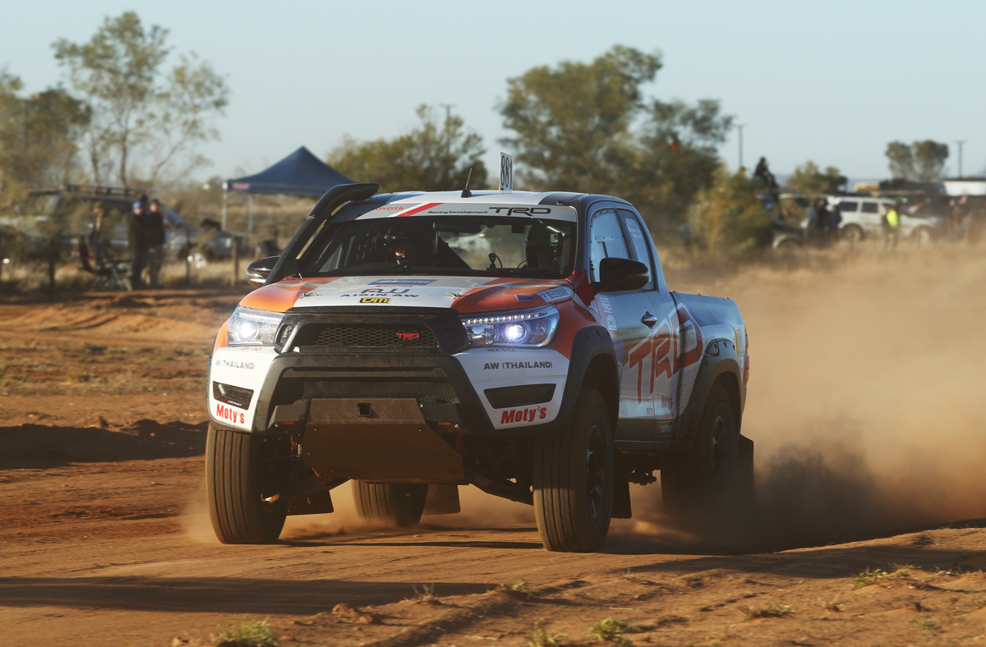

*TRD’s Toyota Hilux racing across the desert sand*

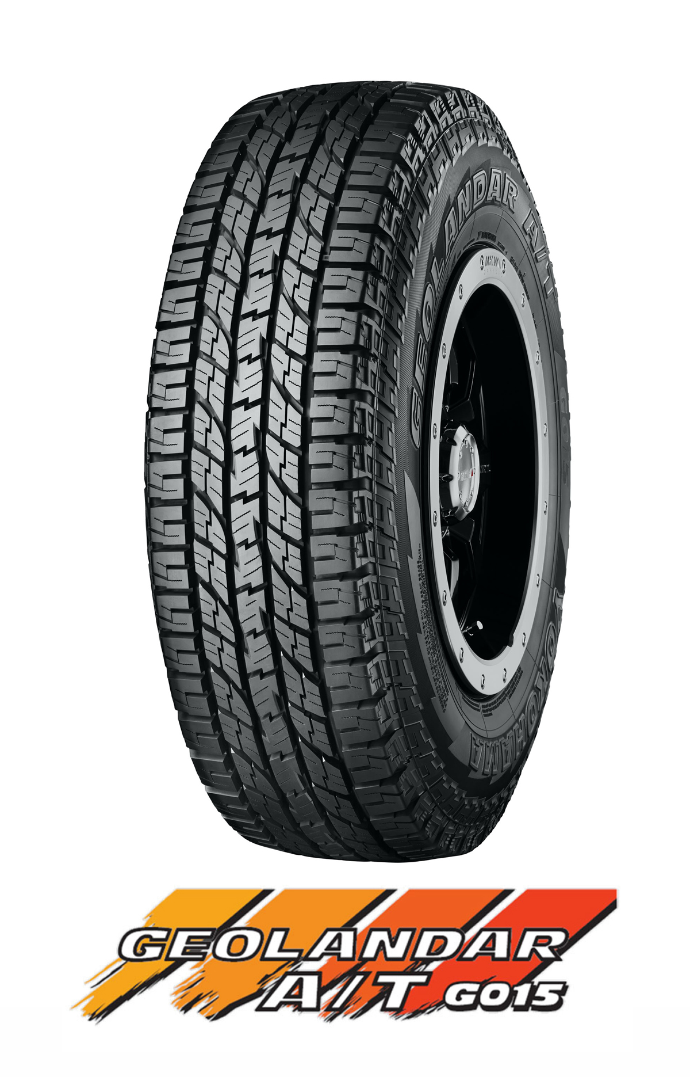

*Geolandar A/T G015 - Tyre shown in photo is LT size*